Table of Contents
Business Description 3
Target Audience 3
Market Opportunity 4
Mobile Marketing Strategy 4
Campaign Objectives 4
Mobile Marketing Channels Used 4
Content & Messaging Strategy 5
Integration with Other Marketing Channels 6
Competitor Analysis & Differentiation 6
Value Proposition and Competitive Advantage 7
Campaign Execution Plan 8
Promotion Strategy 8
Implementation Timeline 8
Monetization Strategy 10
Risks and Mitigation Strategies 10
Bibliography 11

Part One: Theoretical Part
Business Name: Amman Wardrobe
Industry: Fashion Retail

Business Description
Wardrobe Amman is a Jordanian mobile application that allows people to reach to different clothing retailers in the market. The application would have multiple options to the customers whether they were luxury or fast fashion clothing products. The application would cover different areas and different styles of clothing whether they were casual, smart casual, formal, and it would have a men’s and a women’s section with a girls’ and boys’ section on the other hand in order to target as many customers as possible and in order to reach to as many customers in the market that would be interested in the products as possible as well.

Target Audience
The ideal customers are males and females in the market that would range from the age of 14 to 55 which would be interested in the latest clothing trends and which would be interested in obtaining their clothing products in a really convenient approach and way through the mobile application.
The application is going to be targeting middle to high income people as it would offer both fast fashion brands with affordable luxury brands in it, which means that the pricing strategy is going to be ranging from low to medium pricing strategy and is going to align with the needs of many different groups in the market in return.
The brand would be targeting professionals and students that would be interested in imposing their looks and in imposing their styles for the people that would be around them, and that have style as their main passion.

Market Opportunity
The clothing market of Jordan is expected to reach 1.58bn USD in 2025, and an annual growth is expected to reach 1.79% from 2025 to 2029, which demonstrates the growth of the demand on this type of market. On the other hand, many customers in the market have demonstrated their acceptance of different types of e commerce and mobile applications for purchasing their products, and this includes different consumers in the Middle Eastern market including Jordan. (Statista, 2025)

Mobile Marketing Strategy

Campaign Objectives
- Increasing the level of brand awareness among Jordanian youth
- Boosting the engagement of the customers with mobile-exclusive offers and allowing them to have interactive content within the application in order to find themselves in the application and to find all their needs in one place.
- Driving an experience through the mobile application and not just a product purchase experience, but an enjoyable one that the customers would be satisfied with.

Mobile Marketing Channels Used
Amman Wardrobe is going to be using SMS marketing through SMS messages where they would be informing the customers on the newest offers that they would be able to obtain with the mobile application. Flash sales, new arrivals, and exclusive discount are going to be sent to the customers.
Push notifications are going to be implemented through the mobile application where the customers would have the ability to make sure that they would be getting the best offers, and where the customers would have the ability to make sure that they would be catching up with the newest offers that are offered for them through Amman Wardrobe, and just through Amman Wardrobe which would allow them to see the privileges that they can obtain through the application. Also, new drops of Amman Wardrobe are going to be announced through the push notifications, and this is going to help in integrating the updates that are occurring with the application for the customers.
Loyalty rewards are going to be applied, and many customers would be able to obtain them through the application of Amman Wardrobe. Cart reminders are going to be a part of the processes, and they are going to be a main part of reminding the customers that they have the chance to catch up with the offers that are there for them in the application.

Content & Messaging Strategy
The tone of the application is going to be a gentle and a friendly one where the customers would have the ability to know that the notifications would be coming from Amman Wardrobe. On the other hand, the product images that are going to be available are going to be clear and are going to be showing the closest details of the products that would be featured in the application.
The application is going to allow the customers the features of seeing what would suit the piece that they have selected among the other options that would be available for them, and this is going to be helpful from the aspect of cross-selling, and is going to allow the customers the option of styling their products that they have with them.
Consumer-generated content is going to be encouraged in order to allow the customers to take part in the marketing aspect and to be involved in it (Santos, 2021), which would allow the customers to have more trust and more confidence in the brand and in the products that are offered by the brand and to feel that it is close to them, and that it is a store and an application that speaks to them in many different types of ways.

Integration with Other Marketing Channels
Amman Wardrobe is going to be integrating their content into different social media platforms, and they are going to be focusing on the social media platforms that allow a high visual featuring approach, and this would include Instagram, Tik Tok, and Facebook.
The content of social media is going to be featuring different styles, and is going to be integrated through different approaches which would make the content interactive, which would include influencer marketing as the influencers would be trying the pieces and would be allowing the customers to see how they would look on them, and they would be giving their opinions on them. This would be featured in the influencers’ pages, and it would be featured in the Amman Wardrobe social media pages. (Roger, Preece, Innes, & Spasić, 2022)
Email marketing is going to be a part of the channels that are going to be integrated, and it would include emailing the customers their loyalty offers and the different updates of their shipments and of the orders that they have placed on the other hand, which is going to be complementary to the application and its features.

Competitor Analysis & Differentiation
There are many clothing retailers in Jordan, and a lot of consumers purchase products from Arab mobile applications and platforms that would take a long time to be delivered to them such as Voga Closet and Namshi. On the other hand, most of the consumers in the clothing Jordanian market obtain their products through brick-and-mortar stores through malls and retailers and through flag stores, which makes the online experience missing. (Weldali, 2024)

Value Proposition and Competitive Advantage
The application is going to have different features that would allow it to be different and distinctive than other retailers, and among them would be the real time tracking of the delivery and of the shipments. On the other hand, the customers would be able to shop their favorite products through one place and through an online market that would be easy for them to access in many different types of ways.
The mobile application is going to allow the customers to be a part of the marketing campaign through encouraging consumer-generated content (Roger, Preece, Innes, & Spasić, 2022), which would allow the customers to be engaged, and this would mainly include the Jordanian customers in many different types of ways and approaches through the social media platforms and through allowing interactions from the customers in return.
This application is going to have many sections that are going to be relevant to the Jordanian consumers and this would include a section for Hijabi women that are going to be modest and that are going to be choosing modest collections. They are going to have their own section, and as international brands offer modest styles, this would be easy, and this would allow a higher level of reach and a higher level of attraction for customers that have many styles and that would like to express themselves through their apparel and through their looks and the clothes that they would be selecting.
Local Jordanian influencers are going to be engaged, and as Jordan is rich with influencers and as there are many options to choose from this aspect, it would be easy to find many different human figures that would represent the brand and that would represent the mobile application and what it aims to achieve with the customers from interactions and from engagement, and would also contribute to the desired experience that would be delivered to the customers in many different ways.

Campaign Execution Plan

Promotion Strategy
The business is going to be following a multi-channel approach that would be integrated through many styles and through many aspects and areas of practice such as influencer marketing and consumer-generated content marketing and encouraging that (Roger, Preece, Innes, & Spasić, 2022), which is going to make the promotional plan mainly based on interacting with the customers and mainly to be based on interacting with the different desires that the customers have with a business that is involved in this field and that is involved in fashion and the different implications of it.
Partnerships with different distinctive brands that are not available anywhere else, and partnerships with emerging and rising local Jordanian brands with the integration of the content strategy that has multiple channels and that implements influencer marketing would help the brand to spread and would help the store to reach the different areas that it is striving for when it comes to achieving and obtaining the objectives that it has been settled for.

Implementation Timeline
Month | Actions
Month 1 | - Finalizing app development  - Testing the application  - Onboarding the influencers that are going to take part in the marketing activities.  - Starting in Amman
Month 2 | - Launching the application into the marketing  - Starting the influencer marketing activities  - Collecting the early user feedback in order to enhance the performance of the application and to reach to a higher level of customer satisfaction.
Month 3 | - Completing the campaign and encouraging consumer-generated content to be shared on social media in order to share the word of mouth of the customers and the experiences of the customers.  - Expanding to different governances in Jordan.

Monetization Strategy
The brand is going to have a standard browsing approach, and is going to give different influencers different discounts in order to make sure that they would be seeing the different influencers that have a better performance at attracting the customers and allowing them to have their promotional codes. This is going to help in allowing the best performed influencers to stand out and to be identified.

Risks and Mitigation Strategies
There might be different issues and risks that would be associated with how the application would be functioning, and this is going to be from a developmental aspect and area, and this is going to be mitigated through conducting an extensive beta testing and establish a responsive in-app customer support channel.
Another risk that might be present and that might occur would be the slow adoption of the customers of the mobile application, and this is going to be through allowing the customers to have their own promotional offers on the first time they would be purchasing the products from the mobile application in order to encourage for more usage and in order to attract more and more customers.
Finally, data privacy concerns would be present in the application as the users would be sharing their personal data and even their financial data with the application, and this is going to be mitigated through developing a high level cyber risk assessment, and through investing in enhanced cybersecurity systems, as this type of risk is sensitive and might make the customers skeptical of the application, and might cause a lot of problems in return.

Bibliography
Santos, M. L. (2021). The “so-called” UGC: an updated definition of user-generated content in the age of social media . Online Information Review.
Roger, D., Preece, A., Innes, M., & Spasić, I. (2022). Real-Time Text Classification of User-Generated Content on Social Media: Systematic Review. IEEE Transactions on Computational Social Systems.
Statista. (2025). Apparel - Jordan. Retrieved from Statista: https://www.statista.com/outlook/cmo/apparel/jordan
Weldali, M. (2024, September 28). Jordan’s clothing industry experiencing steady rise since beginning of year – stakeholders . Retrieved from Jordan Times: https://jordantimes.com/news/local/jordans-clothing-industry-experiencing-steady-rise-beginning-year-–-stakeholders

Part 2: Practical Part
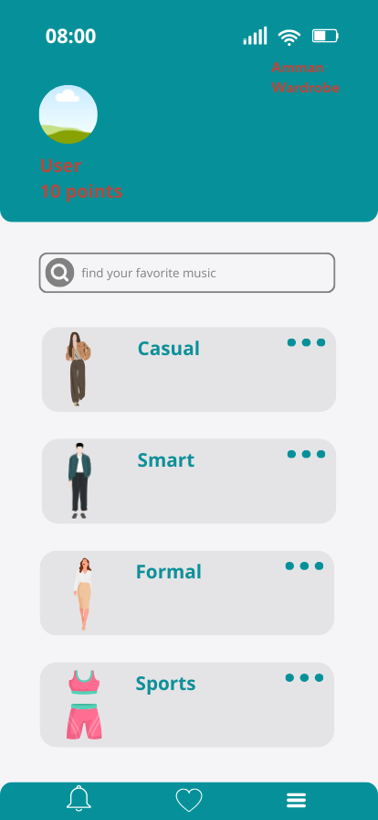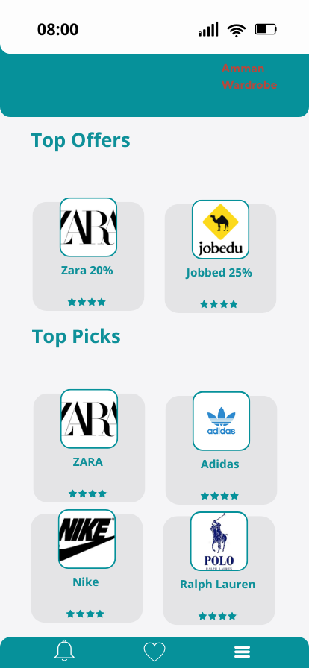
Offers and clothing categories. It is flexible and it would allow the customers to navigate through the application in an easy way.
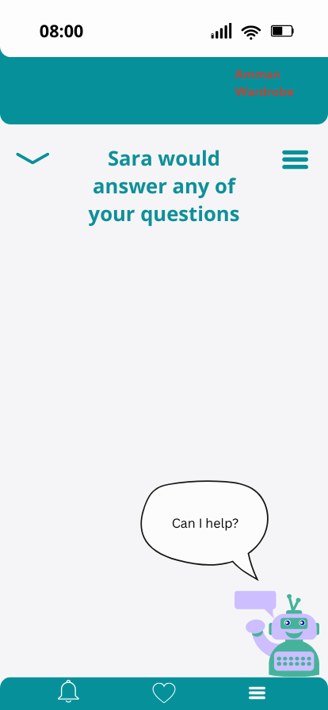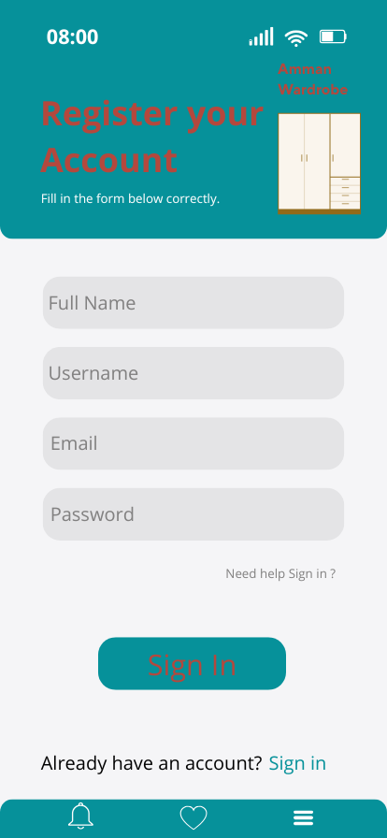
Sign in and sign up page with the chatbot page
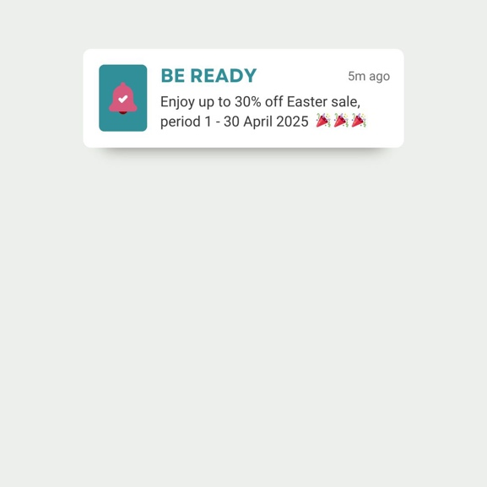
Push Notifications

